**Steps:**

1. Create a collection called “MobilePhones” in “MobileDB” database
2. Add 10 records
3. Create a HTML page as mentioned in the picture 1. Enter the data and on clicking of “Add Products” button, Save the data to “MobilePhones” collection using MongoClient and Insert()
4. On successful saving of data, Show a alert “Product added successfully” and redirect to “Product Details” HTML page(see the picture 2). This page should retrieve data from “MobilePhones” collections and display all records including the 10 records entered in step 2.

**Picture – 1**

Save Product

In Stock

Price

Name

**Product entry screen**

**Picture – 2**

**View Product Details**

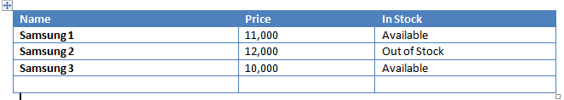

|  |  |  |
| --- | --- | --- |
| Name | Price | In Stock |
| Samsung 1 | 11,000 | Available |
| Samsung 2 | 12,000 | Out of Stock |
| Samsung 3 | 10,000 | Available |